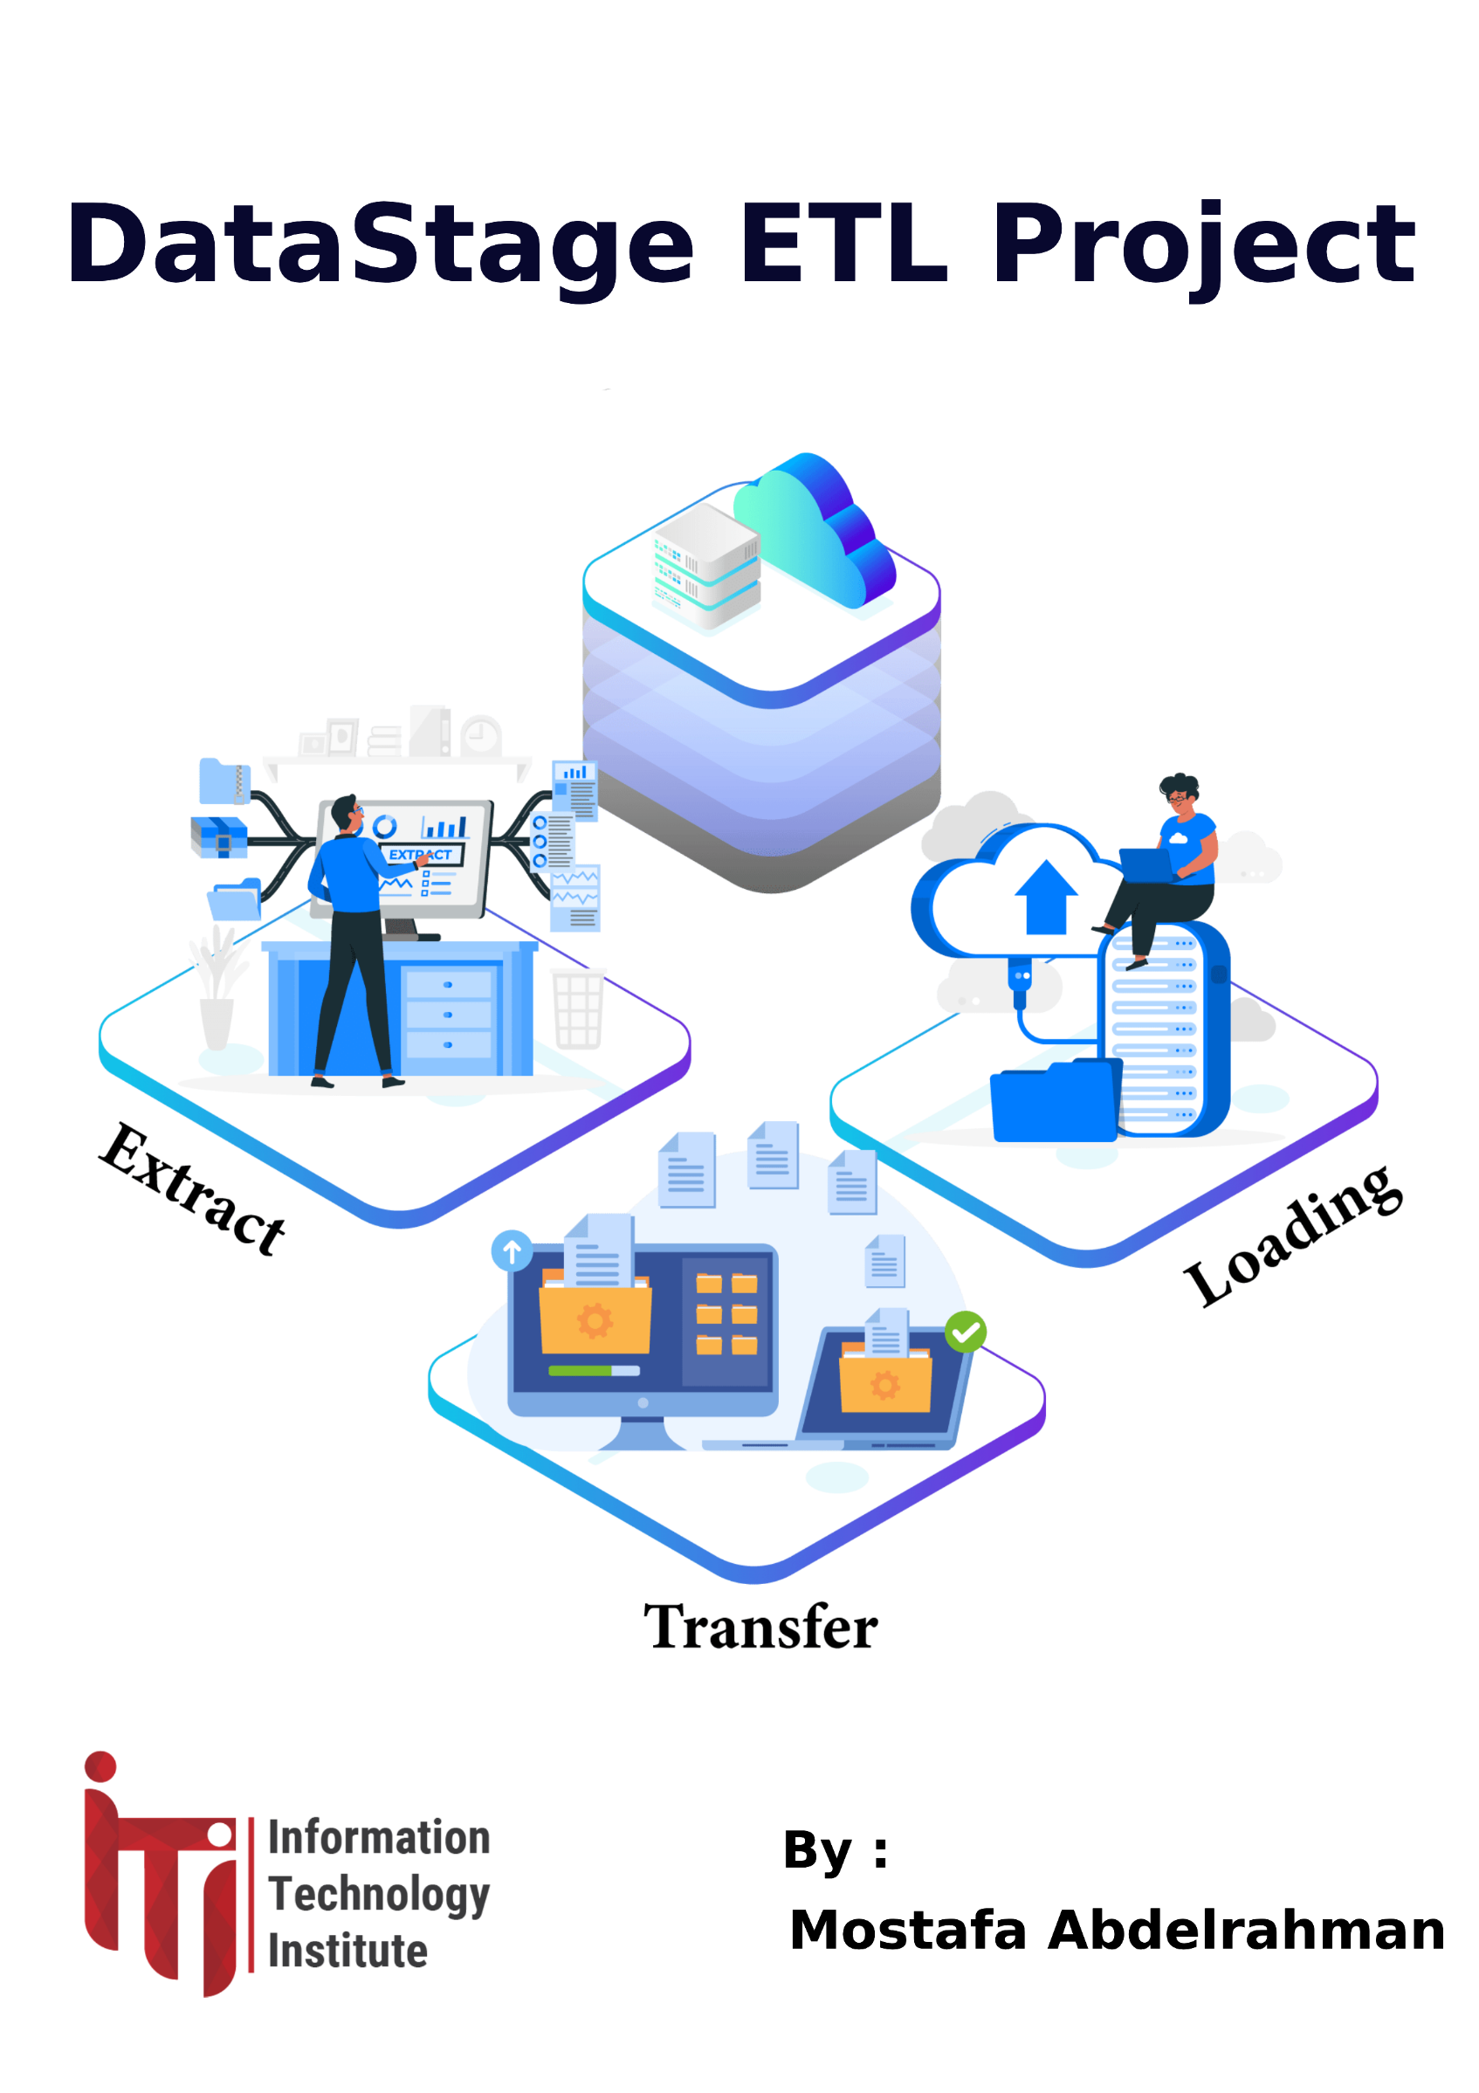

**DWH to Data Marts ETL Simulation Project**

In this case study, we develop an ETL solution to load data into files or databases based on business needs. The case involves three dimensions: product, retail, and customer, with a fact table "transactions."

**First Requirement:**

Create a data mart displaying each transaction for each customer based on customer type (citizen or foreign) with some transformations.

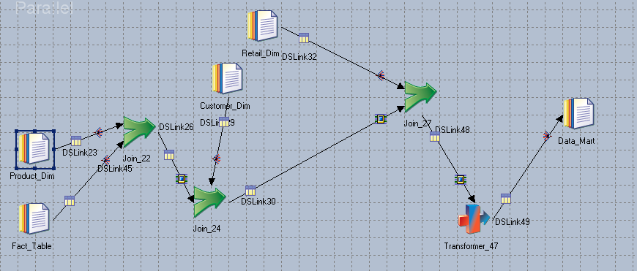

**Second Requirement:**

As a business need >>> display count of all transactions for each customer for each store.

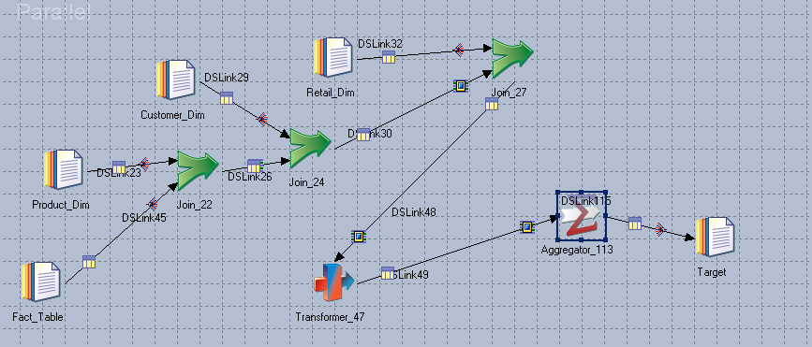

**Third Requirement:**

As a business need >>> Display max profit made by which customer type.

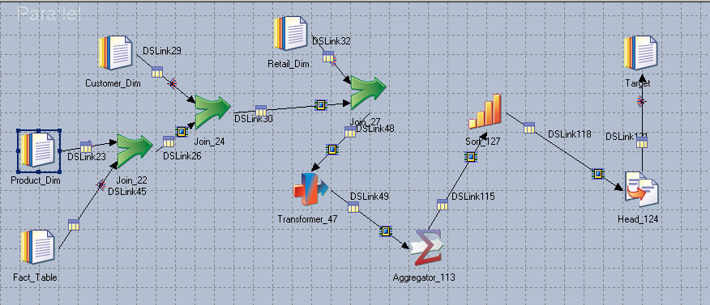

**Fourth Requirement:**

As a business need >>> Based on which customer make profit , give them Bonus

Equation = Annual_Incomek$ * SpendingScore*100

